Summer Meeting and Stadium Site Tour

SunTrust Park Jobsite
1171 Circle 75 Parkway Southeast – Gate 1 entrance
Atlanta, GA

Thursday, August 18, 2016, 8:00 AM

8:00 AM  8:00 AM – 8:30 AM | ARRIVAL at Gate 1  REGISTRATION (Breakfast will be served)
8:30 AM – 9:20 AM | Introduction to SunTrust Park and American Builders  Lisa Capicik, American Builders
9:20 AM – 9:30 AM | BREAK
9:30 AM – 11:00 PM | SunTrust Jobsite Exposures  - Heat/hydration Study  - Silica Exposures  Hilarie Schubert Warren, Georgia Tech Research Institute
11:00 – 12:00 | Jobsite Walking Tour
12:00 Noon | Conclusion
Note: Please keep in mind that this is an active construction site. As such you must have on hard-soled, close-toed shoes - like construction boots or hiking boots. No Toms, no sneakers, no flip flops or sandals. The stadium will provide hard hats and safety glasses, but you may bring your own if you prefer. No recording devices allowed.

DIRECTIONS
Parking for the jobsite is limited, so attendees are encouraged to carpool.
We will meet at Gate 1 Entrance (green arrow on Image 1) promptly at 8:00 AM to be led to the meeting room. Gate 1 is directly across from 1000 Circle 75 Parkway. For directions, click here: https://goo.gl/maps/wyyX4SSZbH42.
There are parking decks located at 900, 1000, and 1100 Circle 75 Parkway. (The parking deck at 900 Circle 75 (red arrow)seems to be the largest and frequently has many construction trucks parked there, so that deck seems the most friendly to guests.)
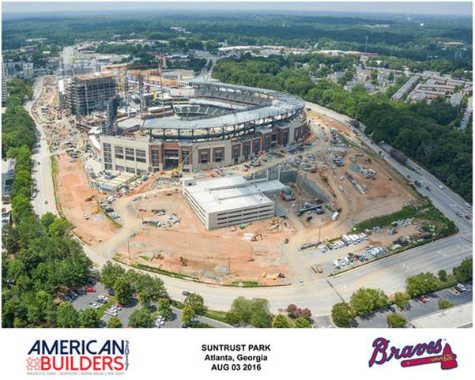
Image 1: Aerial picture showing location of Gate 1 Entrance.

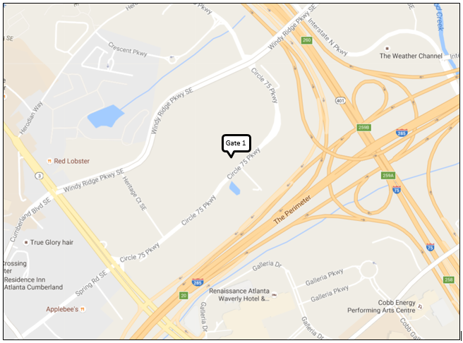
Image 2: Map of the area.
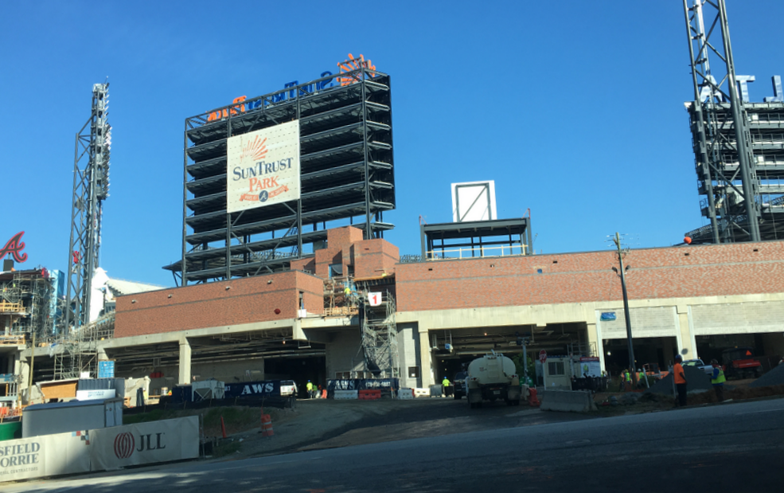
Image 3. Picture of Gate 1 Entrance

